**COMPUTER NETWORKS**

**NAME: M.ISTAFA MALIK**

**ROLL: P190033**

**SECTION: BSCS-5A**

**1:** First Configure the PCs as shown above and verify the connection using ping command.

Step 1: Create the following topology using two end devices (PC’s) and connecting them through a Cross over wire.

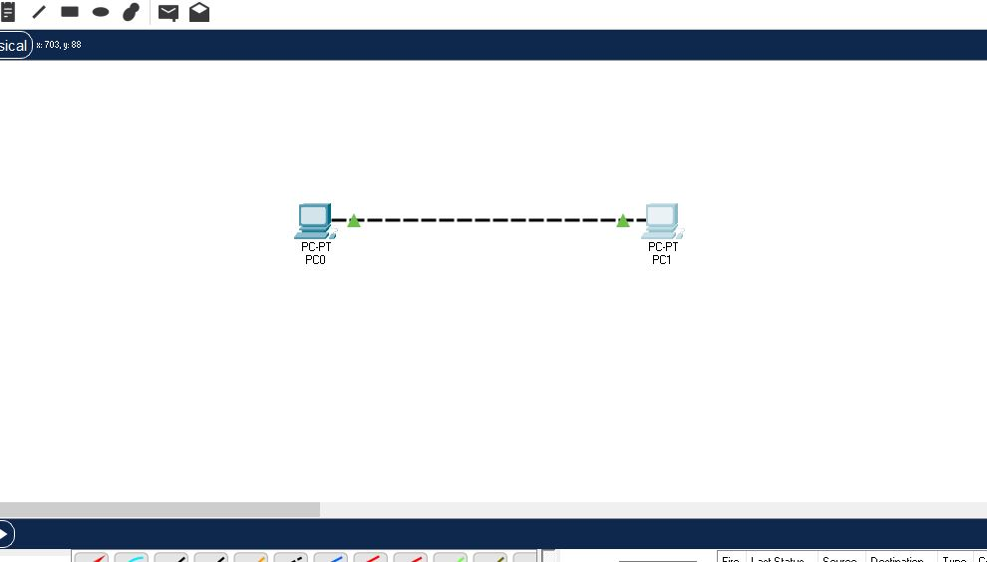

Step 2: Now double click on PC0 a dialog

Box will appear on the screen, select Desktop and then select IP configuration and assign the following IP 192.168.1.1 and subnet mask 255.255.255.0 (which will be assigned automatically).

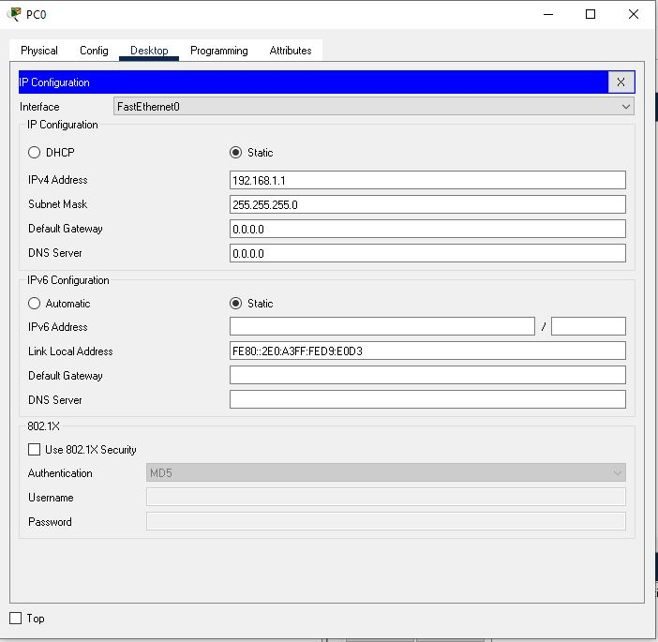

Step 3: Now do the same for the second PC1 but assign the following IP 192.168.1.2

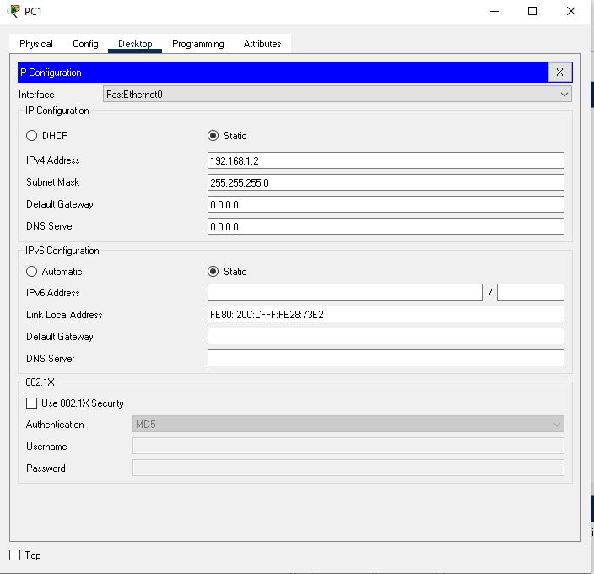

Step 4: Now open Command Prompt of PC0 and type the following command ping 192.168.1.2 which is the IP of the second PC. This will give us verification of the connection.

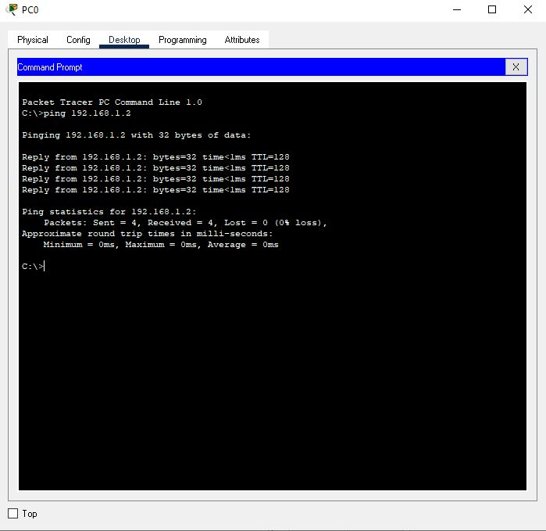

Step 5: Now do the same for the second PC only this time use first PC’s IP i.e. 192.168.1.1

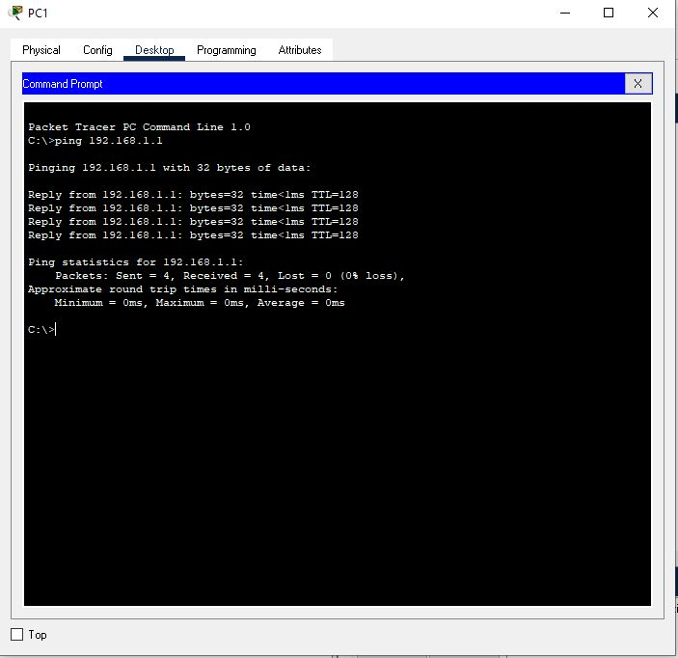

2: Configure PC1 as follow: IPv4: 192.168.1.1 Subnet mask: 255.255.255.0

And PC2 as: IPv4: 192.168.2.1 Subnet mask: 255.255.255.0

Step 1: Here is the topology



Step 2: Now we update the IP and subnet mask same way we assigned it the first time on PC0.



Step 2: Again update the IP on PC1 with the given IP in the Task.

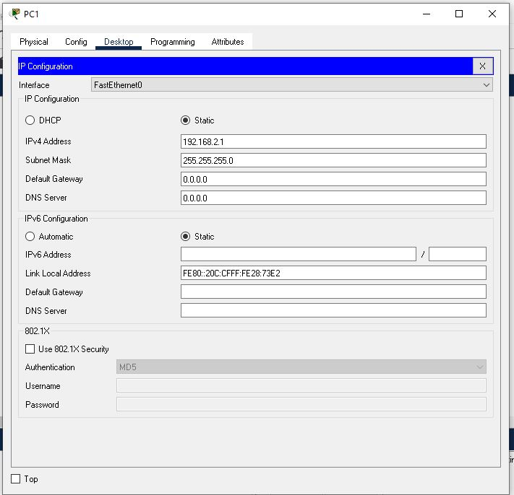

Step 4: Now we use ping command to see if the system works or not.

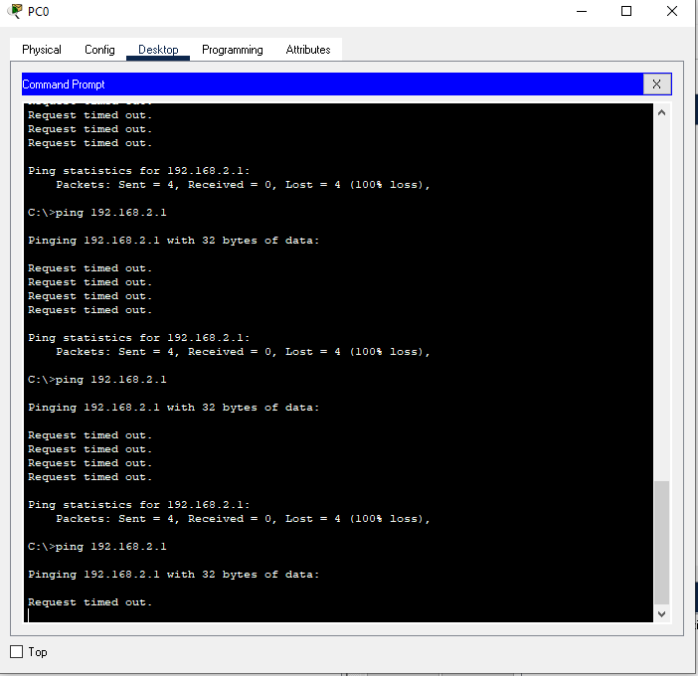

**Reason:**

It is showing error, the reason is network change that occurred when we changed the second PC’s IP from 192.168.1.2 into 192.168.2.1.

3: Configure PC1 as follow: IPv4: 192.168.1.1 Subnet mask: 255.255.0.0

And PC2 as: IPv4: 192.168.2.1 Subnet mask: 255.255.0.0

Step 1: Our Topology



Step 2: update the Subnet Mask in the IP section of the PC’s.

PC0

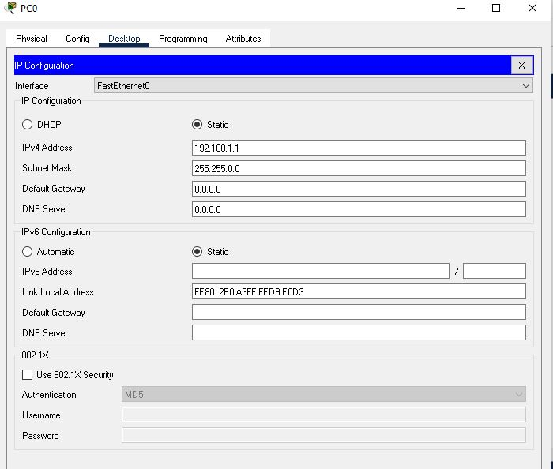

PC1

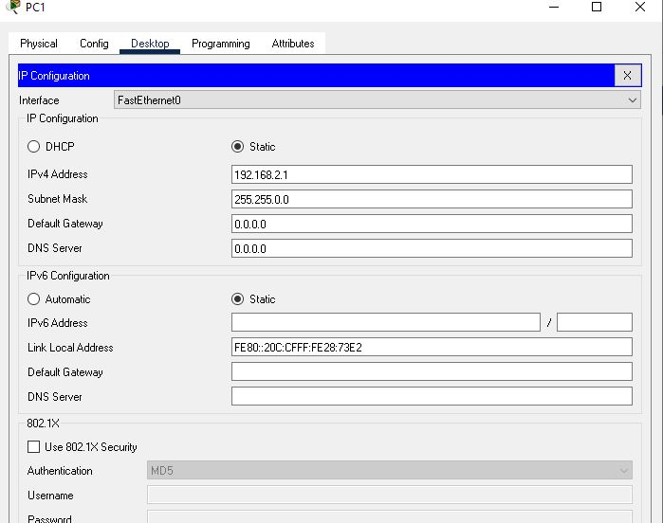

Step 3: Now we use ping command to check our system.

PC0

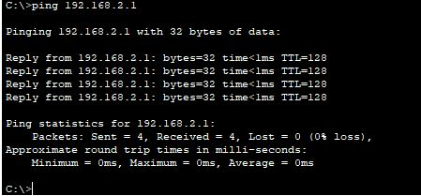

PC1

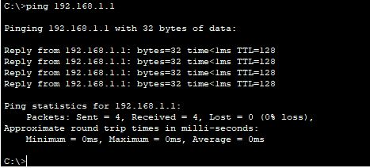

**Reason:**

It works, the reason is that the subnet mask defines our network and in this case it is 255.255.0.0 means 192.168 is the only part of the network that needs to be identical

Task: Construct and simulate Hub with End Devices.

Step 1: Create the following topology.

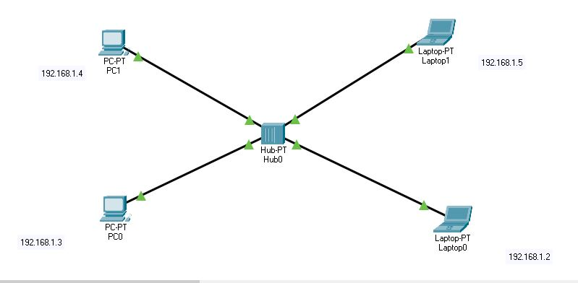

Step 2: Assign all the end devices (PC’s) their IP’s as given in the dialogue boxes beside them.

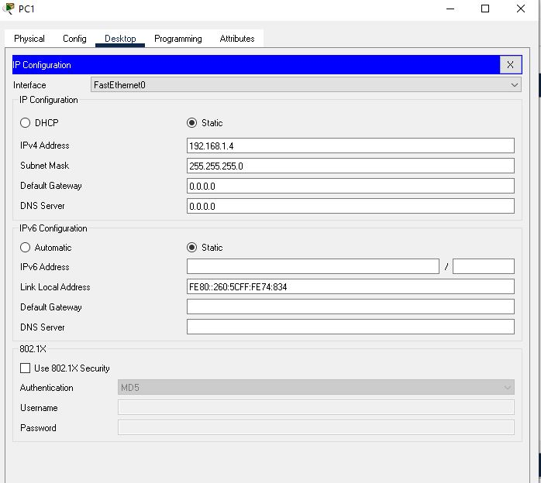

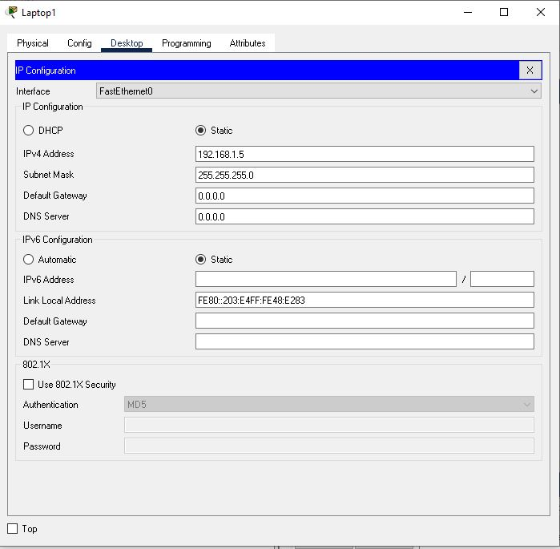

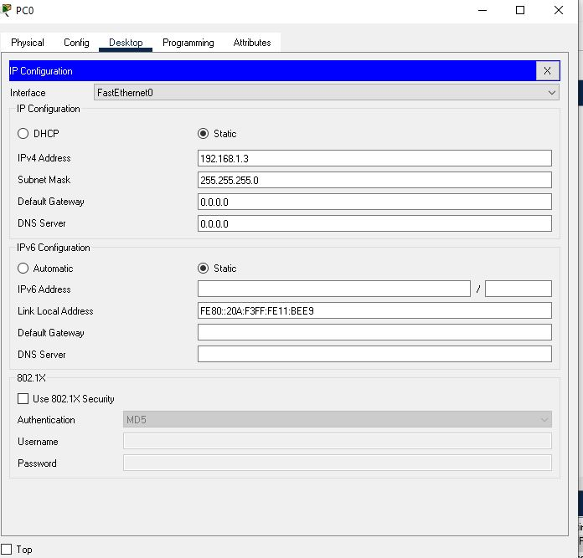

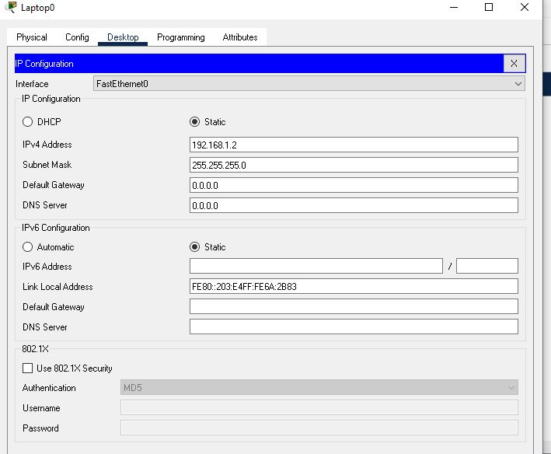

Step 3: Now let’s simulate in real time to see if it works or not.

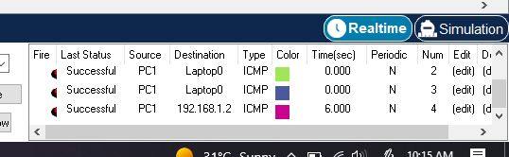

It’s a success.

Step 4:

Now let’s simulate it in simulation to see how it works

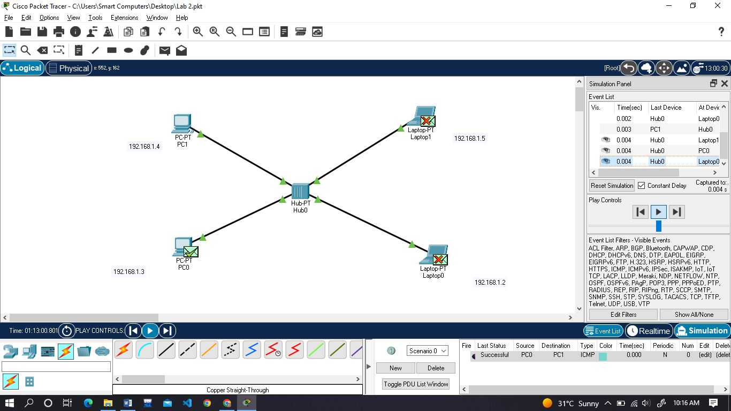

It’s a success again.

Task: Construct and simulate the switch with end devices.

Step 1: Our Topology

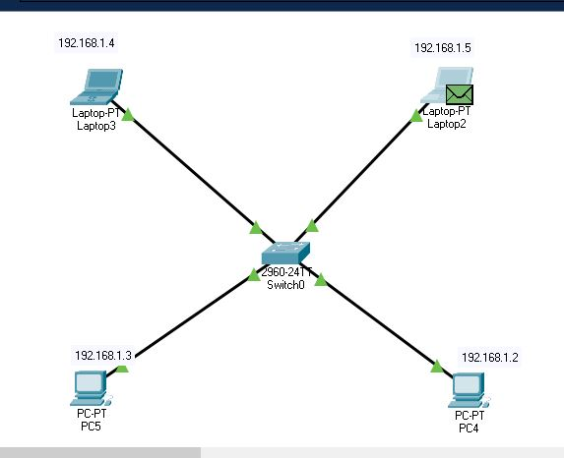

Step 2: Assign IP’s to all PC’s.



Do the same for all the rest with their IP’s

Step 3: Real time

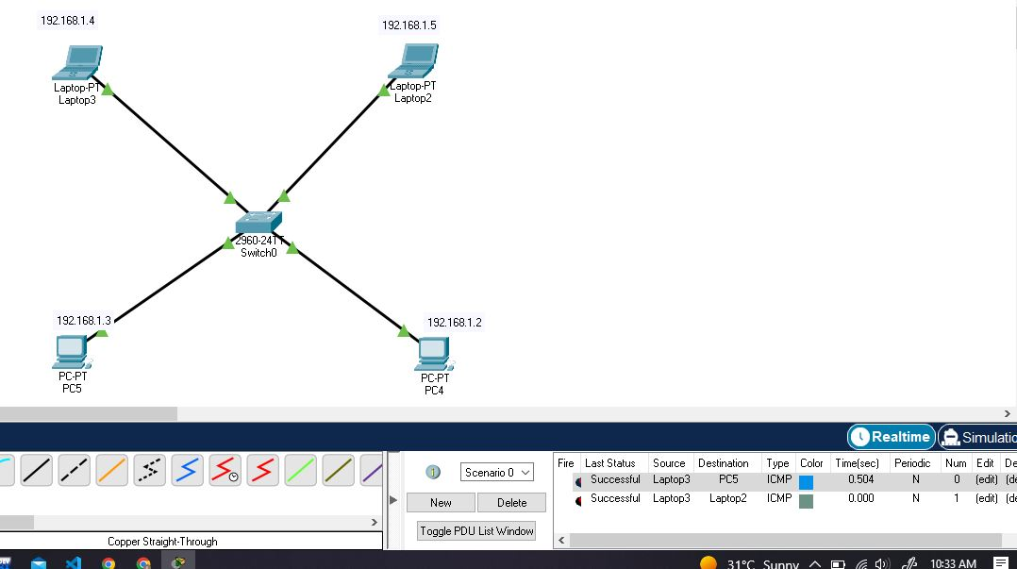

Step 4: Simulation Mode:

1:Packet from Source

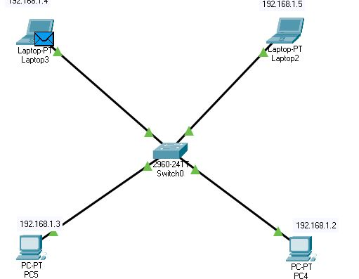

Towards Destination:

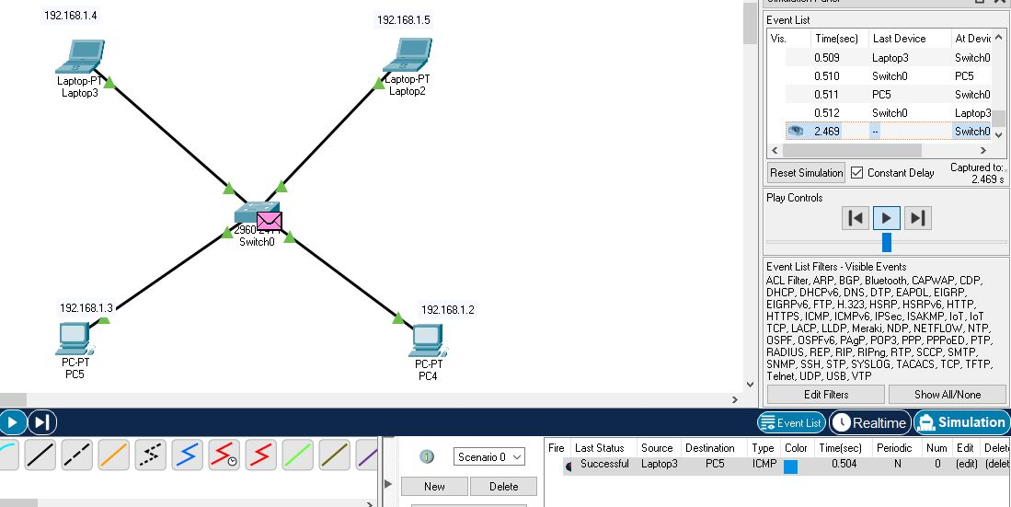

Sucess

